

2024

Standing Race Rules

&

Conditions

***Welcome Racers***

First off, we would like to start by saying welcome to Aussie Outlaws sim racing league

The aim of this league is to provide the best & closes racing we can to the real world & to have some fun while doing that.

2024 will see us run a 15-week race season that will be run fortnightly on a Wednesday night with practice – open qualifying starting at 8pm Melb time.

We will start the race season on the 10th of April with the 1st 2 rounds on Australian tracks before we swing up into the UK for 3 rounds. We will then head over to the USA & Canada for a further 3 races before we head into Europe for racing on some of the best tracks in the world. The last race of the season will see us head to Japan for the 75 min race at Suzuka.

Season 2024 will see us run 2 levels of championship with a Pro class & a Pro-Am class. This will be set out later in this hand out.

Like all motor sport there are rules and regulations that need to be followed & these are lay out in the pages that follow. Please read them as they will help keep us to the high stranded of racing that we all like.

In closing this short welcome, I would like to thank you again for racing with us & wish you the best for season 2024 in your endeavours to become the Aussie Outlaws Every Thing Simulated Champion.

**See you on Track!**

**1. Official Communication**

**1.1** The official email address for Aussie Outlaws is: **aussieoutlawsracingau@gmail.com**

**1.2** All official communications from teams & driver must be sent to our email address. This includes information on team updates, driver line ups, liveries & request for number changes.

**1.3** PMs on Facebook & our discord will not be accepted as official.

**1.4** All communications must have Name, Team Name & race number in them.

**2. Participation Arrangements**

**2.1** Participation online is only possible via registration with our official registration form and subject to acceptance of and compliance with these Terms and Conditions and the rules of iRacing.

**2.2** By participating the user automatically accepts these Terms and Conditions and the iRacing General Competition Rules[**https://www.Iracing.com/competition**](https://www.iracing.com/competition) **and contest rules.**

**2.3** Participants must provide their name, date of birth, country of residence, home state, iRacing ID and email address**.**

**2.4** Internet access is required for participation in the Competition. All costs incurred in the context of participation, such as costs for Internet usage etc will be worn by the participants

**3. Abuse & Foul Language**

**3.1** All members of the league are to treat each other with respect.

**3.2** Foul Language & abuse will not be tolerated in any form including social media.

**3.3** Discrimination against sex, race, religion, or personal beliefs as well as personal insults will not be tolerated.

**3.4** If a member fails to follow this rule, there will be immediate grounds for removal from the league with iRacing being informed of your removal & the reason of the removal

**4.Flags, Lights & Lines**

All flags, lights, pit-lane, and on-track lines rules must be obeyed at all times.

Green Flag means "Go!"  
The track is clear for racing; it will be waved on the first lap of a race, and in a sector following an incident.

White Flag means there is one lap to go.  
The next time you cross the start/finish line, the race will be finished.

Checkered Flag means the race has finished.  
please Keep going around the track & do a cool down lap, if we start doing this now it will get us use to it for when we get the racing broadcast It is not acceptable to press ESC to return to your garage, but in some cases (when the race is being broadcast)

Yellow Flag indicates a "Danger!"  
You must slow down and be prepared to stop. Overtaking in the 'yellow zone' is not allowed in real racing, but most sims do not give a penalty for this. Use common sense to avoid causing further incidents.

Red Flag means the race is being stopped.  
You must slow down and then press ESC to return to your garage. The race will be restarted by the race director.

Black Flag means you must return to your garage, because you have been disqualified from the race.  
This will only happen if you repeatedly ignore warnings. Most sims will show several indications that you must pit for a drive-through or stop/go penalty. Ignoring these warnings will result in you being excluded from racing.

Black Flag with orange circle means you have car damage. You must return to your garage, because your car needs to be repaired.

Blue Flag with yellow strip will be shown to drivers who are about to be lapped by a driver who is a lap ahead.  
If you are shown a blue flag, you must try to let the faster driver pass as soon as you can safely. You are not expected to move off the racing line unless you can do so safely, preferably on a straight. It is up to the driver behind to indicate his intention to pass, and you should drive your normal line (unless on a straight as described). Do NOT brake heavily, especially in corners and do NOT drive off the track to let someone pass you.

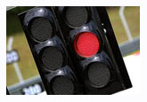Red Light means "Stop!"  
If you see a red light at the exit of the pit lane, it means you are not allowed to join the track yet. You must wait for a green light before doing so. Failure to stop at a red light will result in an immediate penalty. There may be occasions when this does not apply, e.g. if the track's graphics are not working correctly. The Race Director will inform drivers when this is the case.

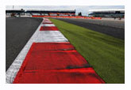 Lines & Kerbs marking the edge of the track.  
Most sims give warnings and penalties automatically. If you get a warning, it means you have exceeded track limits and repeating this will result in a penalty. On some occasions, it is necessary to apply these rules manually, and penalties may be handed out after the race. At all times, you should obey the principle of 2 wheels on the track at all times. This means you must always have at least 2 of your wheels inside the white lines. Where there is no line, the edge of the track (usually coloured grey) is the limit.

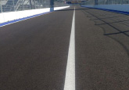 Pit Exit Path is defined by a white line which must not be crossed when you exit the pits.  
Drivers are expected to obey this rule in every official session (Practice, Qualifying and Race).



**5. ENTRIES**

**5.1** All drivers are expected to have read and fully understand the rules & regulations stated in this document.

**5.2** Drivers can only drive for the team they have been registered to.

**5.3** All drivers must sign up using the entry form that is available from web page before they can race.

**6. ELIGIBLE CARS**

**6.1** The only cars that are permitted to compete in the Aussie Outlaws are the current GT3 cars.

Those cars are:

Audi R8LMS EVO II GT3

BMW M4 GT3

Ferrari 296 GT3

Lamborghini Huracan GT3 Evo

McLaren MP4-12C GT3

Mercedes-AMG GT3 2020

Porsche 911 GT3 R (992)

**6.2** Once you have chosen your car you will not be able to change makes unless you change teams or until the beginning of a new season.

**6.3** If you wish to change car make you may seek permission from the league admin so long as it is done in writing.

**6.4** Cars may be painted as you like but MUST NOT have any profanity, adult material or offensive material on them.

**6.5** All political statements are discouraged & may only be displayed with the express permission of the Aussie Outlaws admin.

**6.6** Any breach of 8.4 or 8.5 will see the offender being removed from the server & or removed from the league.

**7. CAR NUMBERS**

**7.1** All entrants will use a car number that they have selected and that has been approved by the Aussie Outlaws admin in all official sessions. If a competitor does not use/display their approved and or allocated car number, then that driver will be disqualified from that round & each round there after that the correct number is not displayed.

**7.2** Numbers 1, 01 (including the champion’s default number) is reserved for the championship winner should he or she wish to return and compete in the next season.

**8. ELIGIBLE DRIVERS**

**8.1** Only drivers who have filled out their nomination form, presented all the required information, have been approved by the ADMIN team and have their race number allocated to them will be allowed to compete in the series. No unauthorized drivers are to be in any of the series specific servers, however they may spectate.

**8.2** All drivers must have an iRacing B class license with a Safety Rating of 2.5 in Road.

**9. Driver’s License**

**9.1** You must have a Road Lic of at least B class with a safety rating of 2.5 & a Irating 0f 500 to race in the Everything Simulated GT3 championship.

**10. Driver’s Championship**

**10.1** The Everything Simulated championship will run a Pro & a Pro-Am championship

**10.2** You will be placed in the Pro Class if when Nominating you have a A class Lic with a Irating of 2000 or above

**10.3** You will be placed in the Pro-Am class if when nominating you have a B or A class with a Irating of 500 to 1999

**10.a Team’s Championship**

2024 we will not be running a team’s championship, however if you are a team, we ask that you fill in a team’s nomination form so we can get drivers & teams in the race reports that will be posted on the web page blog & face book. All team members must run the same make of car.

**11. Driver’s Championship Points**

**11.1** Championship point will be awarded as follows for both Pro & Pro-Am

**11.2** Championship points will be done manually on a spread sheet each week & posted as soon as possible. If you see or you think a mistake has been made with points, please let one of the league admins know & we will fix it.

**11.3** Points & championship standing will be posted in our discord channel by Friday night

**11.4** You must start the race on grid or from pit lane & complete 1 lap to receive championship points

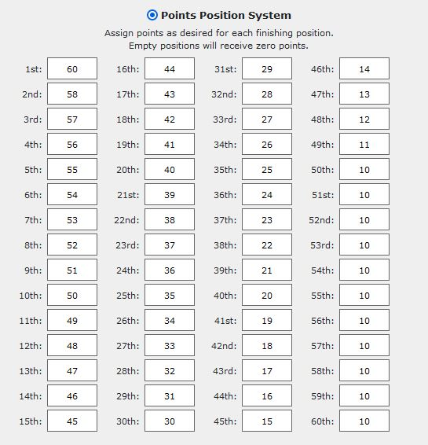

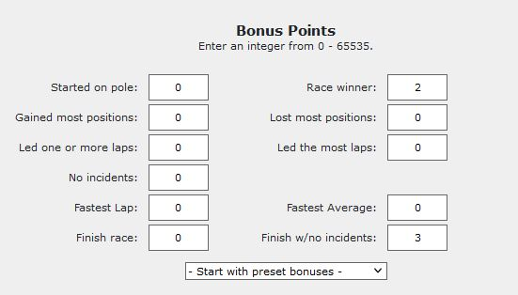

**12. Race set ups**

**12.1** All races will use the current cars as listed in part 6 of this hand out.

**12.2** All races will be open set up.

**12.3** All races will have at least a 45 min open practice / qualifying with the race server going live 8pm Melb time.

**12.4** All races will start with 75% fuel.

**12.5** All races will have Starting + 2 set of tires.

**12.6** All races will use a live weather system where possible.

**12.7** There will be NO fast repairs.

**12.8** All races will be a timed race set at 75 min

**14. Race Control**

**14.1** Race control will be left up to iRacing automated system for all races.

**14.2** All penalties handed out by iRacing are final.

**14.3** NO penalties or black flags will be cleared by race admin.

**14.4** Race admin may remove any driver from a race where they see fit.

**14.5** If race admin feels that iRacing automated system has failed they reserve the right to address the situation as they see fit.

**15. Race Starts**

**15.1** All cars should be side by side nose to tail & within 2 car lengths of the car in front of you.

**15.2** All race starts will be rolling starts

15.3 All Races will start on the green flag/light  
  
**16.A. Overlap**

**16.A.1** Overlap is defined by the front nose of the attacking car being alongside the B-Pillar of the defending car at the turn-in point of the defending car. This is not an exact science, so there is some leeway for Stewards to judge overlap.

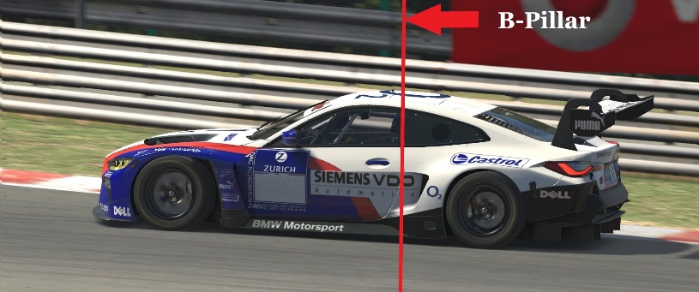

**16. Overtaking   
16.1** It is the responsibility of the car behind to choose a safe point to attempt an overtake, and to do so without causing an incident.  
**16.2** The driver behind must have established overlap to the car in front at the lead driver's turn-in point for the corner before they should attempt an overtake.   
**16.3** If there is no overlap at turn in point, the leading driver has the right to their racing line and does not need to leave space for the attacking driver.

**16.4** If a rear-end collision is predicted in a braking zone, it is recommended to aim for the outside of the corner to avoid contact.  
**16.5** If you gain an advantage from a bump & run or use of the grass you have 2 turns to readdress the move or you may receive penalty   
**16.6** You may move to defend you line once before the braking zone. When you have made that move you can not move a second time.

**17. Off Tracks & Re-Joining  
17.1** If you findyourself off track & out of control you are asked to hold your brakes until you get control of your car, when you have control you then may re-enter the race as long as the track is clear   
**17.3** If there are cars coming you must stop & give way to those cars

**18. Race Protest**

**18.1** Any driver may lodge a protest of an incident that he/she is involved in.

**18.2** You have 30 minutes to lodge a protest after the checked flag has dropped.

**33.3** Race protest forms can be found on the web page under 2024 Rule book & forms.

**18.4** No protest will be accepted unless it’s on the official protest form.

**18.5** If your protest is dismissed or found to be frivolous it will cost you 15 championship points.

**19. Abuse & Foul Language**

**19.1** All members of the league are to treat each other with respect.

**19.2** Foul Language & abuse will not be tolerated in any form including social media.

**19.3** Discrimination against sex, race, religion, or personal beliefs as well as personal insults will not be tolerated.

**19.4** If a member fails to follow this rule, there will be immediate grounds for removal from the league with IRacing being informed of your removal & the reason of the removal  
**19.5** Below is a table of penalties for any breach of this rule

|  |  |
| --- | --- |
| **Abuse & Foul Language Breaches** | |
| ***Excessive Use of Foul language 1st Offence Season*** | ***25 Points & 2 Weeks off*** |
| ***Excessive Use of Foul language 2nd Offence Season*** | ***50 Points + 4 weeks off*** |
| ***Excessive Use of Foul language 3rd Offence Season*** | ***Removal for the season*** |
| ***Abuse towards a Member of the league 1st Offence Season*** | ***50 points & 4 Weeks Off*** |
| ***Abuse towards a Member of the league 2nd Offence Season*** | ***Removal from League with IRacing Informed*** |
| ***Bring the league into disrepute 1st Offence*** | ***20 points & 4 Weeks Off*** |
| ***Bring the league into disrepute 2nd Offence*** | ***Removal from League with IRacing Informed*** |

**20. In Race Communications**

**20.1** All drivers are to be connected to a team, or race channel in the Aussie Outlaws discord channel when in a race server.

**20.2** All general chit chat is to be done though a discord channel.

**20.3** The iRacing radio channels are to keep free for in race communication from the drop of the green flag

**21. Broadcast & Streaming   
21.1** The 2024 season will not be broadcast how we will endeavour to get a highlight package of the race onto Chequered Flag E-Streaming ever week**.  
21.2** We encourage you if you are a steamer to stream the races just let us know so we can get it out there for you



<https://www.youtube.com/@chequeredflagestreaming>

**22. Driving Breaches   
22.1** Driving breaches will fall into one of the following tiers & will be judged on an incident-by-incident base **22.2** All Penalties handed down by the race review are final

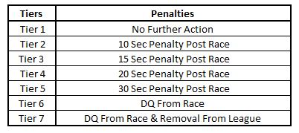

**Race Dates**

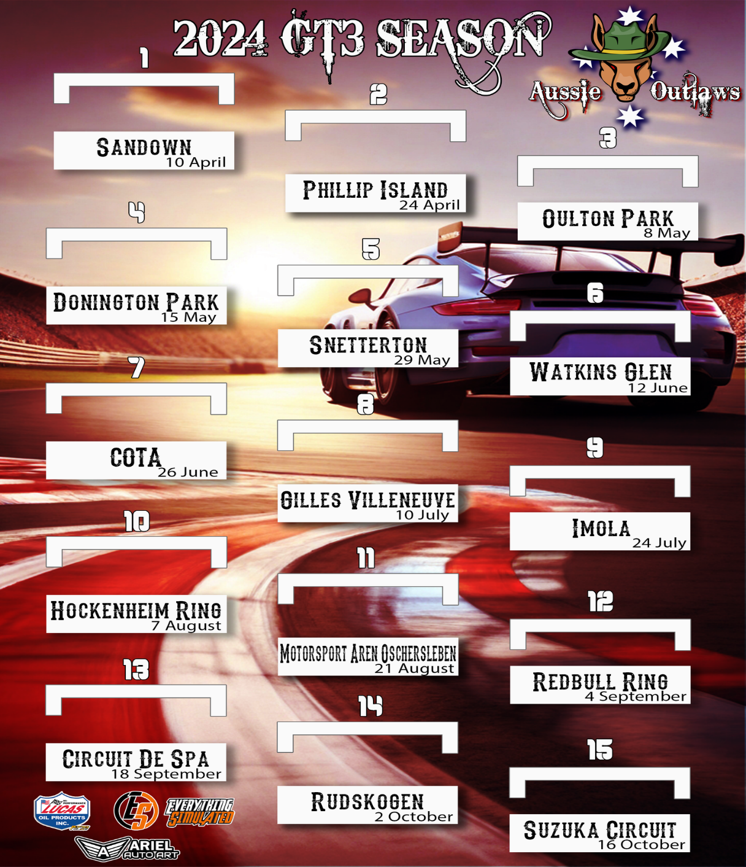

**Key league Personal**

**League Admin   
Jamie Nankervis  
Paul R Drady   
Mark Johansson**

**Race Admin   
Matthew Raymond   
Brett Campbell  
Adam Ariel**