

2024

Standing Race Rules

&

Conditions

**Table of Contents**

Welcome –------------------------------------------------Page 3

* Official Communications –----------------------------- Page 4
* Participation Arrangements –------------------------- Page 4
* Declaration of Consent –-------------------------------Page 4
* Data Protection Notice –-------------------------------Page 4
* General Communications –----------------------------Page 4
* Abuse & Foul Language –-------------------------------Page 5
* Entries –---------------------------------------------------Page 5
* Eligible Cars & Presentation of Cars –----------------Page 5
* Car Numbers –-------------------------------------------Page 5
* Eligible Drivers –-----------------------------------------Page 5
* Driver’s License -----------------------------------------Page 6
* Events –---------------------------------------------------Page 6
* Race Set Ups Page –------------------------------------Page 6
* Race Control –-------------------------------------------Page 6
* Race Start & Restarts –---------------------------------Page 6
* Race Cautions (Oval) –---------------------------------Page 7
* Road Racing Cautions –--------------------------------Page 7
* Blue & Yellow Passing Flags (Road Racing) –-------Page 7
* Lapped Cars (Oval) –------------------------------------Page 7
* Net Code –------------------------------------------------Page 7
* Specific Race Rules to Aussie Outlaws--------------------Page 7
* Pit Lane & Pit Stops –-----------------------------------Page 8
* Race End –------------------------------------------------Page 8
* Post-Race Interview –----------------------------------Page 8
* Tec Issus –------------------------------------------------Page 8
* In Race Communications –----------------------------Page 8
* Teams & Team Points –--------------------------------Page 9
* Drivers’ Championship & Points –-------------------Page 9-10
* Race Results –-------------------------------------------Page 11
* Race Replay ---------------------------------------------Page 11
* Race Protest –-------------------------------------------Page 11
* Penalty Appeal –----------------------------------------Page 11
* Rookie of the Year –------------------------------------Page 11
* Prize Fund -----------------------------------------------Page 11
* Table of Non Lic Breaches -----------------------------Page 12
* Table of Lic Breaches -----------------------------------Page 13
* 2023 Race Calendar ------------------------------------Page 14
* Contingency logos & sponsors -----------------------Page 15
* Key League Personal ----------------------------------Page 16

***Welcome Racers***

First off, we would like to start by saying welcome to Aussie Outlaws sim racing league

The aim of this league is to provide the best & closes racing we can to the real world & to have some fun while doing that.

2024 will see us run a 36-week race season just like the real Nascar & will be made up of a 26-week regular season then a 10 week play off to crown our 2024 Lucas Oils Cup Car Champion.

The race server will open on a Saturday night @ 6:30pm Melbourne time, with a 30 min practice, 5 min 2 lap qualifying for ovals or a 15 min 2 lap qualifying for Rd circuits. The races will be full open set ups, 100 % race distance, fuel & tire allocation just like real world Nascar.

Season 2024 will see us run 3 marquee events that will be trophy races, & they will be the Lucas Oils Daytona 500 on the 24/2/24, The ANZAC Cup on the 27/4/24 & the final one will be the Memorial Day 600 on the 1/6/24.

Like all motor sport there are rules and regulations that need to be followed & these are lay out in the pages that follow. Please read them as they will help keep us to the high stranded of racing that we all like.

Season 2024 will see 95% of our races broadcast live on Chequered Flag E-Streaming with the other 5% being highlight’s package from each race. Broadcast races will be live from around 7pm Melbourne time & run the full length of the race with post-race interviews from the top 3 in each race.

In closing this short welcome, I would like to thank you again for racing with us & wish you the best for season 2024 in your endeavours to become the Aussie Outlaws Lucas Oils Cup Champion.

**See you on Track!**



**1. Official Communication**

**1.1** The official email address for Aussie Outlaws is: **aussieoutlawsracingau@gmail.com**

**1.2** All official communications from teams & driver must be sent to our email address. This includes information on team updates, driver line ups, liveries & request for number changes.

**1.3** PMs on Facebook & our discord will not be accepted as official.

**1.4** All communications must have Name, Team Name & race number in them.

**2. Participation Arrangements**

**2.1** Participation online is only possible via registration with our official registration form and subject to acceptance of and compliance with these Terms and Conditions and the rules of iRacing.

**2.2** By participating the user automatically accepts these Terms and Conditions and the iRacing General Competition Rules[**https://www.Iracing.com/competition**](https://www.iracing.com/competition) **and contest rules.**

**2.3** Participants must provide their name, date of birth, country of residence, home state, iRacing ID and email address**.**

**2.4** Internet access is required for participation in the Competition. All costs incurred in the context of participation, such as costs for Internet usage etc. will be borne by the participants.

**3. Declaration of Consent**

**3.1** The participants agree that their names will appear in live streams and press releases handled by the organizer, Aussie Outlaws, Broadcasting partners, and any relevant organisation that has an interest in the advertised series without remuneration.

**3.2** All participants that gain a podium in either a race, round or championship shall agree to attend the post-race presentation or show. Failure to do so will result in the participant losing 40 points from there championship tally from the round results, & or DQ from that Round of the championship.

**3.3** Participants under the age of 18 years of age will be exempt from rule 3.2

**4. Data Protection Notice**

**4.1** The participant data given in the course of participation will be collected, processed, and used by the Organizer solely for the provision of the Competition. This data will be handled in strict confidence and will not be shared with third parties, apart from with cooperating partners commissioned with the provision of the Competition, (Chequered Flag, and its partners) and will not be used for advertisement purposes.

**4.2** Participants can at all times demand that the Organizer provide them with information in relation to what personal data has been stored, demand that the Organizer modify or delete this data and withdraw their consent to the use of this data.

**5. GENERAL COMMUNICATIONS**

**5.1** We will use either our official Facebook group or Discord server for general communications.

**5.2** Our Facebook group is by invitation only, once a registration form is approved then you will receive an invitation to the group.

**5.3** All Discord server members must have their name & race number set to the same as their iRacing name to make it easy to identify drivers and team members. If this is not done you will receive a 5-point penalty & drive thou or a in the next race that you take part in.

**5.4** All team channels will be locked with only team members having access to team channels. The in-race channel will be open to all members of the league.

**6. Abuse & Foul Language**

**6.1** All members of the league are to treat each other with respect.

**6.2** Foul Language & abuse will not be tolerated in any form including social media.

**6.3** Discrimination against sex, race, religion, or personal beliefs as well as personal insults will not be tolerated.

**6.3** If a member fails to follow this rule, there will be immediate grounds for removal from the league with IRacing being informed of your removal & the reason of the removal

**7. ENTRIES**

**7.1** All drivers are expected to have read and fully understand the rules & regulations stated in this document.

**7.2** Drivers can only drive for the team they have been registered to.

**7.3** All drivers must sign up using the entry form that is available from web page before they can race.

**8. ELIGIBLE CARS**

**8.1** The only cars that are permitted to compete in the Aussie Outlaws are the current iRacing Nascar cup cars.

Those cars are:

NASCAR Cup Next Gen Chevrolet Camaro ZL1

NASCAR Cup Next Gen Ford Mustang

NASCAR Cup Next Gen Toyota Camry

**8.2** Once you have chosen your car you will not be able to change makes unless you change teams or until the beginning of a new season.

**8.3** If you wish to change car make you may seek permission from the league admin so long as it is done in writing.

**8.4** Cars may be painted as you like but MUST NOT have any profanity, adult material or offensive material on them.

**8.5** All political statements are discouraged & may only be displayed with the express permission of the Aussie Outlaws admin.

**8.6** Any breach of 8.4 or 8.5 will see the offender being removed from the server & or removed from the league.

**9. CAR NUMBERS**

**9.1** All entrants will use a car number that they have selected and that has been approved by the Aussie Outlaws admin in all official sessions. If a competitor does not use/display their approved and or allocated car number, then that driver will be disqualified from that round & each round there after that the correct number is not displayed.

**9.2** Race numbers must be placed on the door panels on either side of the car, the roof and rear of car or as per NASCAR Rules.

**9.3** Numbers 1, 01 (including the champion’s default number) is reserved for the championship winner should he or she wish to return and compete in the next season.

**9.4** The numbers 50, 75, 100 and 125 will be reserved for drivers reaching that mile stone race, that driver may use that number for the round only. 1st in best dressed.

**10. ELIGIBLE DRIVERS**

**10.1** Only drivers who have filled out their nomination form, presented all the required information, have been approved by the ADMIN team and have their race number allocated to them will be allowed to compete in the series. No unauthorized drivers are to be in any of the series specific servers, however they may spectate.

**10.2** All drivers must have a iRacing B class license with a Safety Rating of 2.5 in both Oval & Road.

**11. Driver’s License**

**11.1** You must have an oval Lic & a Road Lic of at least B class with a safety rating of 2.5 to race in the Lucas Oils Cup car championship.

**12. Events**

**12.1** All Aussie Outlaws Car cup car events will be held on a Saturday night with the server going live @ 6:30 pm Melbourne time whether it being daylight saving or standard time.

**12.2** All events will have 30 min practice.

**12.3** All oval races will have 5 min 2 lap qualifying.

**12.4** All Road circuit races will have 15min 2 lap qualifying.

**12.5** If a time change is required, we will endeavour to give as much notification as possible.

**12.6** Season 2024 will be run over 26 weeks regular with a 10-week playoff for Cup cars.

**12.7** All drivers must qualify for each round to be eligible for bonus points.

**12.8** Admin have the right to remove any driver it sees fit to for breaches of the rules laid out in this document.

**13. Race set ups**

**13.1** All races will use the current cars used in real-life NASCAR Cup racing.

**13.2** All races will be open set up.

**13.3** All Oval races will have at least a 30 min practice.

**13.4** All oval races will have 5 min 2 lap qualifying.

**13.5** All Road circuit races will have 15min 2 lap qualifying.

**13.6** All Road races will have a 45 min warm up.

**13.7** All race will be the same as real world in distance.

**13.8** All races will start with 100% fuel & 100% tire allocation as per real world.

**13.9** All races will use a live weather system where possible.

**13.10** There will be NO fast repairs.

**13.11** All Oval races will have 3 Green/white/Checker if required.

**14. Race Control**

**14.1** Race control will be left up to iRacing automated system for both oval & road races.

**14.2** All penalties handed out by iRacing are final.

**14.3** All black flags handed out by iRacing are final.

**14.4** NO penalties or black flags will be cleared by race admin.

**14.5** Race admin may remove any driver from a race where they see fit.

**14.6** If race admin feels that iRacing automated system has failed they reserve the right to address the situation as they see fit.

**15. Race Starts & Restarts**

**15.1** All cars should be side by side nose to tail & within 2 car lengths of the car in front of you.

**15.2** Pole car must stay within 8 car lengths of pace car by turn 3 & remain within 5 mph or 8 kmph of pace car speed.

**15.3** Pole car must not speed up or slow down after the pace car has left the racing surface.

**15.4** Initial race start is to be on the green flag/light.

**15.5** Race restarts are on the lead car, he / she must adhere to rule 15.2 until the pace car has left the racing surface, then the lead car may restart the race at any time when in the restart zone.

**15.6** All drivers must hold their lane until the race has started or been restarted.

**15.7** When the race is started / restarted you may then pass to the outside of your lane prior to start line.

**15.8** All race starts & restarts will be looked at post-race by the race admin.

**16. Race Cautions (Oval)**

**16.1** All drivers are to slow when safe to do so.

**16.2**  All drivers are asked after slowing to catch the pacing lane as safely and as quick as they can.

**16.3** All drivers are asked to remain on the low line (pole line) to give the wave around & lucky dog cars an unobstructed lane to get passed.

**16.4** If for some reason you cannot maintain the pace car speed or catch the pacing lane quickly you must stop & tow your car.

**16.5** All race cautions will be looked at post-race.

**17. Road Racing Cautions**

**17.1**  iRacing local cautions should be adhered to.

**18. Blue Yellow Passing Flag Road Racing**

**18.1** Drivers are to hold there racing line.

**18.2** Slow when safe to do so to allow the faster car to pass unimpeded if you are a lap or more down from the race leader.

**18.3** Communicate on the iRacing open race channel with passing driver where you are going to let, he / she by.

**18.4** It is up to the passing car to make the pass safely with the help of the car being passed.

**19. Lapped Car (Oval)**

**19.1**  If you fall 3 or more laps down you are not to Obstruct the lead lap cars.

**19.2** If you are 3 or more laps down you are to move off the preferred racing line when the leading cars approach you.

**19.3**  If you fall 6 or more laps behind lead lap cars, you are not to Obstruct / race any car that is not on the same lap as you.

**19.4** Communicate with the race leaders on iRacing open radio channel of your intensions.

**20. Net Code**

**20.1**  Net Codes will be looked at as contact.

**21. Specific Race Rules to Aussie Outlaws**

**21.1** All iRacing rules apply to all Aussie Outlaws races as well as their sporting code.

**21.2** All drivers that take the green flag/light & complete 1 racing lap will receive race points.

**21.3** You must be drug free & we ask that you remain under .05 if you are having a drink.

**21.4** No passing below the pole line, if you have your 2 left wheels on or below the pole line you will be classed as below the pole line.

**21.5** Any driver that is found to be guilty of deliberate wrecking will be DQ from race & loss of 50 points in the championship.

**21.6** There is to be no deliberate blocking until the last 15 laps of any race & then you can only move once to block.

**21.7** If you spin or leave the race surface you must not re-enter the race surface until it is safe to do so.

**21.8** If you wreck, we ask that you apply your brakes until you come to a stop.

**21.9** Where possible & safe to do so keep moving as not to bring out a caution.

**21.10** No B pillar rule will be applied Aussie outlaw races as there is none in NASCAR.

**21.11** Any drive found to be using any part of the outside/inside wall & Aamco rail to further & or gain a position under green flag racing will be DQ from race & will serve a 4-week suspension from all competition.

**22. Pit Lane & Pit Stops**

**22.1**  If you fake a pit stop & can’t make it back to the racing surface without crossing an unbroken line you must make your stop.

**22.2** Whilst on the racing surface you must be no more the 1.5 car widths off the pole line to enter pit lane.

**22.3** If you enter pitlane from below the pole line it’s up to you to give way to the cars that enter from the correct pit entry.

**22.4** You must stay as far right as possible in pit lane until you are 7 pit bays away from your pit bay.

**22.5** After your service you must move back to the far right as possible of pit lane when leaving your pit bay & leaving pit lane.

**22.6** After your service it is up to you to re-enter the race & racing surface in a safe manner without impeding the drivers on the race surface.

**22.7** Pit Lane entry advice will be announced on the event notice.

**22.8** Any driver using the wrong pit entry will be charged with an unsafe pit entry. If unsure ask the question.

**23. Race End**

**23.1** All drivers are asked to keep race pace until you get though turn 2 after the checkered flag is shown, then you may slow down.

**23.2** All drivers are asked to return to pit lane before you disconnect from the server.

**23.3** Race winner is asked to come back to the start/ finished line do your burn outs then park on the start line.

**23.4**  No other drivers are permitted to engage in post-race burn outs / celebrations.

**23.5** If you do a post-race burnout & you are not the race winner you will be DQ from the race.

**24. Post-Race Interview**

**24.1** The top 3 drivers are required to attend the post-race interview. (Loss of 40 points if driver is a no show).

**24.2** Top 3 drivers are asked to enter the green room & wait for the commentators to bring you into the broadcast booth.

**24.3** No other driver is to the enter the broadcast booth post-race unless they are invited to do so. (Loss of 10 points).

**25. Tec Issues**

**25.1** Any driver that is found to be blinking or have bad internet lag will be asked to go rear of field to try & fix the issues.

**25.2** If the issues are not fixed, one of the race admins will ask you to park your car. You will receive points for the race as long as you have completed 1 lap.

**26. In Race Communications**

**26.1** All drivers are to be connected to a team, or race channel in the Aussie Outlaws discord channel when in a race server.

**26.2** All general chit chat is to be done though a discord channel.

**26.3** The iRacing radio channels are to keep free for in race communication from the start of qualifying.

**27. Race Teams & Team Points**

**27.1** There needs to be at least 7 teams for a team’s championship to take place.

**27.2** Race teams must be named 2 weeks from the start of the 2024 season (09/02/2024).

**27.3** No team may have more than 4 drivers in the team.

**27.4** The 4 drivers must be paired & keep that pairing for the whole season to make an A & B team. No driver pairings may be changed unless the driver is being replaced from the team.

**27.4** No driver sub’s will be permitted.

**27.5** A driver may be replaced without written notification sent to league admin via email at least 48 hours prior to race day. The driver to be replaced must not drive for that team again in that season.

**27.6** All team members must drive the same make of car.

**27.7** Single car teams are permitted.

**27.8** Team points will be driver pairings added together to give team round points from the drivers’ championship.

**27.9** Driver bonus points will be added to team points.

**27.10** Drivers penalty’s will be taken in account.

**27.11** The team with the most points at the end of week 36 will be crowned team’s champion.

**28. Drivers’ Championship & Chase**

**28.1**  The driver’s championship will be run over 36 weeks.

**28.2** To be eligible for championship points you must take the green flag or start the race from pit lane.

**28.3** To be eligible for championship points you must complete 1 lap of the race.

**28.4** To be eligible for bonus points you must qualify.

**28.6** You must compete in 20 of the 26 regular season races to make the chase.

**Place Points Per Race**

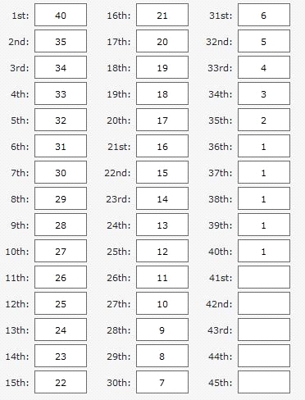

NOTE: If more than 40 cars 41st to 43rd will get 1 point as per real world

**Bonus Points**

Below are the bonus points on offer each round. To be eligible for any bonus points you must qualify for the race.

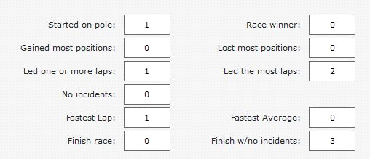

**29. Race Results**

**29.1** All race results & championship points will be recorded on Sim Racer Hub [www.simracerhub](http://www.simracerhub/)**.**com

**29.2** All race results will be deemed provisional until the post-race review is completed.

**29.3**  All race results & race reports will be posted to our oval steward’s report channel on discord by Sunday afternoon & at that point they will be classed as official.

**30.Race Penalties**

**30.1** All penalties that are handed down by the race review are final.

**31 Strike System**

**31.1** We will use a strike system this year for set incidents & they are listed below.

**31.2** For every 5th strike you will receive a Rear of field.

**31.3** For every 10th strike you receive you will receive a 1-week suspension.

**31.4** For every 5th race you have clean 1 strike will be removed from your tally.

**32. Race Replay**

**32.1** All drivers are asked to keep their race replay for 1 week after the race if they can.

**33. Race Protest**

**33.1** No race cautions may be protested as they are looked at in post race review.

**33.2** Any driver may lodge a protest of an incident that he/she is involved in.

**33.3** You have 30 minutes to lodge a protest after the checked flag has dropped.

**33.4** Race protest forms can be found on the web page under 2024 Rule book & forms.

**33.5** No protest will be accepted unless it’s on the official protest form.

**33.6** If your protest is dismissed or found to be frivolous it will cost you 15 championship points.

**League Sponsors**

This year it is not compulsory to run the league sponsors logos but we do ask if you can fit them on the car some where it would be good. The main one is the Lucas oils logo. They can be found on our Discord channel un league sponsors.

**Driving Breaches**

Below are the table of driving breaches with the minimal penalties

|  |  |
| --- | --- |
| **Abuse & Foul Language Breaches** | |
| ***Excessive Use of Foul language 1st Offence Season*** | ***25 Points & 2 Weeks off*** |
| ***Excessive Use of Foul language 2nd Offence Season*** | ***50 Points + 4 weeks off*** |
| ***Excessive Use of Foul language 3rd Offence Season*** | ***Removal for the season*** |
| ***Abuse towards a Member of the league 1st Offence Season*** | ***50 points & 4 Weeks Off*** |
| ***Abuse towards a Member of the league 2nd Offence Season*** | ***Removal from League with IRacing Informed*** |
| ***Bring the league into disrepute 1st Offence*** | ***20 points & 4 Weeks Off*** |
| ***Bring the league into disrepute 2nd Offence*** | ***Removal from League with IRacing Informed*** |

|  |  |
| --- | --- |
| **Low Risk Driving Breaches** | |
| ***Not Staying to the right on Pit Lane entry / Exit Non-Contact*** | **1 Strike** |
| ***Not Moving Off or Moving Off Before the Field is Released - Pre-Race*** | **1 Strike** |
| ***Not Staying within 2 Car Length of the car in front on Race Start or Re-start*** | **1 Strike** |
| ***Not Staying within 5 MPH / 8KMPH of Pace Car Race Start or Re-Start*** | **1 Strike** |
| ***Not Staying within 2 car lengths of the Pace Car Race Start or Re-Start*** | **1 Strike** |
| ***Jump start before green light / Flag*** | **2 Points** |
| ***Passing To the Inside on Race Start or Re-Start before start line*** | **2 Points** |
| ***Changing Lanes Before Race Start or Re-Start*** | **2 Points** |
| ***Unsafe Pit Entry / Exit - Non-Contact*** | **1 Strike** |
| ***Not obeying blue/yellow passing flag*** | **1 Point** |
| ***Not catching next car in pace line quickly or in a reusable fashion under Caution*** | **1 Strike** |
| ***Not Display Correct Race Number (per Round)*** | **DQ from Race** |
| ***Loss of Race Protest*** | **15 Points** |

|  |  |
| --- | --- |
| **Mid-Level Driving Breaches** | |
| ***Self-Spin Bring Out a Caution / Deliberate*** | **0 Points / 10 points** |
| ***Not taking appropriate action to avoid a Wreck*** | **1 Strike** |
| ***Passing below pole line (both left wheels on or below pole line)*** | **2 Points** |
| ***Not Holding Your Brakes on While Wrecking*** | **3 Points** |
| ***Unsporting like driving non-contact*** | **3 Points** |
| ***Deliberate Blocking Prior to The Last 15 laps of The Race*** | **10 Points** |
| ***Impacting Race Battles as a Lapped Car (Without Contact)*** | **5 Points** |

|  |  |
| --- | --- |
| **High Level Driving Breaches** | |
| ***Contact Causing a Caution*** | **racing incident or 5 points** |
| ***Unsafe Pit Entry / Exit - With Contact*** | **3 Strikes** |
| ***Not Staying to the right on Pit Lane Entry / Exit with Contact*** | **3 Points** |
| ***Impeding A Driver with Contact*** | **5 Points** |
| ***Unsporting like driving with contact*** | **10 Points** |
| ***Unsafe Race Re-Entry Causing a Wreck*** | **10 Points** |
| ***Impacting Race Battles as a Lapped Car (With Contact)*** | **5 Points** |
| ***Deliberately / Intentionally Causing a Wreck or Caution*** | **DQ + 100 Points &/0r Removed from league** |

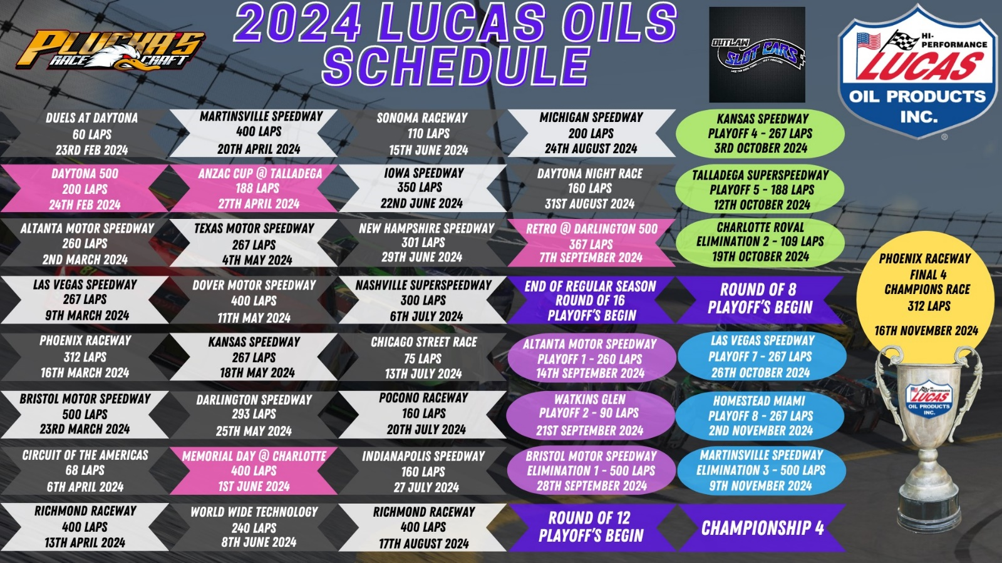

**Race Set up**

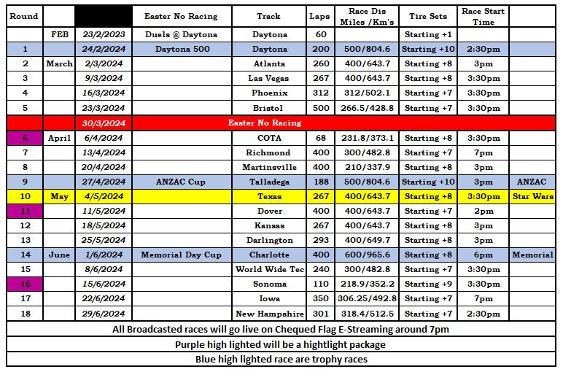

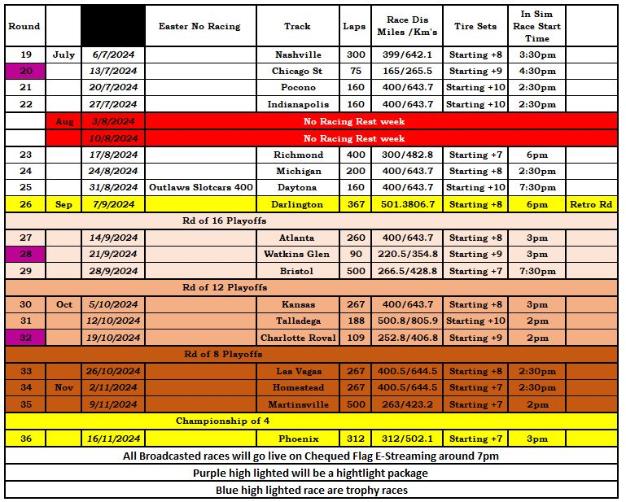

**Key league Personal**

**League Admin   
Jamie Nankervis  
Paul R Drady   
Mark Johansson   
  
Race Admin   
Matthew Raymond   
Brett Campbell  
Adam Ariel**